|  |
| --- |
| **SOURCE BASED QUESTIONS ANSWERING GUIDE** |

**1. Inference**

**Definition**: Making a logical conclusion based on evidence from the source and contextual knowledge.

* Making an inference **IS NOT** copying, describing or paraphrasing the source.

**Sample Questions**:

1. *What can you infer from Source A about the living conditions during the Japanese Occupation?*
2. *What can you infer from Source B about the Japanese soldiers’ attitude toward the locals?*
3. *Is the cartoonist a supporter or opponent?*

**Steps**

1. Study the question carefully and identify the issue in the question.
2. Make an **inference** based on the issue.
   1. Do not copy or paraphrase words from the source.
3. Give **evidence** to support your evidence.
   1. You can copy sentences/describe the source when you give evidence.
4. **Explain** the evidence in your own words to support your inference.

**Sample answer:**

I can infer that the Japanese were very violent **[INFERENCE].** This is evident in Source A which shows a Japanese soldiers drawn as a large gorilla destroying the village **[EVIDENCE].** This suggests that the Japanese caused a lot of death and destruction during the invasion of Singapore. Many people lost their homes and loved ones because of the Japanese brutality **[Explanation].**

**2. Message**

**Definition**: Understanding the message the author intended to convey.

**Sample Questions**:

1. *What is the message of Source C about the Japanese Occupation in Singapore?*
2. *What message does the author of Source D want to convey about the impact of Japanese rule?*

**Steps**

1. Make an inference -> What is the main message the author is trying to tell us?
2. Give evidence from the source.
3. Explain the evidence.
4. Give Contextual knowledge to strengthen your answer.
   1. Contextual knowledge means knowledge from the textbook.

**Sample Answer**

The message is that the Japanese brought hardship to Singapore **[MAIN MESSAGE]**. This is shown in Source B, which depicts long food queues and unhappy faces **[EVIDENCE]**. The image suggests that life under Japanese rule was difficult and filled with shortages. People were struggling to survive, and life was very hard **[EXPLANATION].** From my knowledge, I know that food rationing was carried out during the Japanese Occupation to help solve the food shortage problem. However, even with rationing, people still did not have enough food as very often food at the ration centres will run out **[CONTEXTUAL KNOWLEDGE].**

**3. Purpose**

**Definition**: Understanding **why** the source was created and its **intended impact** on the **audience**.

**Sample Questions**:

1. *Why did the Japanese publish this propaganda poster?*
2. *What was the purpose of the speech given by the Japanese governor in Source E?*

**Steps**

1. Identify the author. -> who created the source?
2. Identify the **audience** -> who is the source meant for?
3. Select an **action word**.(refer to the table below for a list of action words).
4. Give an inference.
5. Give evidence + explanation.
6. Explain the **expected reaction / intended outcome** of the audience.
   1. What does the author hope the audience will do?
7. State the context.
   1. What was going on when this source was created?

**Sample Answer**

The Japanese **[AUTHOR]** published this poster to convince **[ACTION WORD]** locals in Singapore **[AUDIENCE]** that the Japanese were kind rulers who treated everyone well **[INFERENCE]**. This is evident in the source which shows a Japanese soldier carrying children who were waving Japanese flags and smiling. This suggests that the Japanese were caring and did not treat people harshly **[EVIDENCE+EXPLANATION]**. By potraying a positive image, the Japanese hope that locals in Singapore will view the Japanese favourable and support their rule / stop resisting them **[REACTION]**.

This poster was published in 1942, when Japan had occupied Singapore. The locals opposed Japanese rule hence to win over their support the Japanese used propaganda poster such as these change their opinions about the Japanese **[CONTEXT]**.

**LIST OF POSSIBLE ACTION WORDS**

| **Action Word** | **Definition/Explanation** | **Example Use** |
| --- | --- | --- |
| **Convince** | Persuade the audience to adopt a specific viewpoint or take a particular action. | The author wants to convince locals to cooperate with the Japanese government. |
| **Criticize** | Highlight the flaws or wrongdoings of someone or something. | The poster was created to criticize the Allies for their actions during the war. |
| **Reassure** | Calm the audience's fears or doubts. | The Japanese published this to reassure locals that they would be treated fairly. |
| **Praise** | Emphasize the positive qualities of someone or something. | The poster aims to praise the Japanese army for their efforts in rebuilding society. |
| **Warn** | Alert the audience about potential dangers or consequences. | The source warns locals not to resist the Japanese or face severe punishment. |
| **Encourage** | Motivate the audience to act in a certain way or feel a particular emotion. | The leaflet was designed to encourage locals to support the Japanese rule. |
| **Educate/Inform** | Provide information to increase knowledge or understanding. | The document was created to educate locals about Japanese policies. |
| **Promote** | Advocate for or advertise a particular cause, idea, or policy. | The source was made to promote Japanese cultural superiority to the locals. |

**4. Comparison**

**Definition**: Identifying and explaining similarities and differences between sources.

**Sample Questions**:

1. *How far do Sources C and D differ in their portrayal of the Japanese rule?*
2. *In what ways are Sources A and B similar in their depiction of local experiences during the Japanese Occupation?*
3. *How far does Source A agree with Source B. (must use agree/disagree in answer and not similar/different)*

**STEPS**

1. State if you are doing a similarity or difference.
2. State the basis of comparison.
3. Give evidence from both sources.
4. Explain the evidence.

**Sample Answer (DIFFERENCE)**:

**Basis:** Both sources differ in how they portray the treatment of locals by the Japanese.

* Source A: States that the Japanese treated the locals harshly.
  + **Evidence:** This is evident in Source A, which shows Japanese soldiers forcing locals into labour camps.
  + **Explanation**: This suggests that the Japanese imposed strict and oppressive policies, causing suffering to the locals.
* Source B: However, Source B shows that the Japanese treated the locals fairly.
  + **Evidence:** This is evident in Source B, which depicts Japanese soldiers distributing food to the locals.
  + **Explanation:** This suggests that the Japanese sought to gain the locals’ support by providing aid and maintaining goodwill.

**Sample Answer (SIMILARITY)**:

**Basis**: Both sources are similar in highlighting the significant influence of the Japanese on the locals' daily lives.

* Source A: Shows that locals were directly impacted by harsh policies, such as forced labour.
  + **Evidence:** For instance, the source states, "…locals were rounded up to build railways."
* Source B: Also highlights the Japanese influence by showing their attempts to control local attitudes.
  + **Evidence**: It states, "…the Japanese distributed food and encouraged loyalty to the empire."

**Explanation:** Both sources indicate that the Japanese had a profound and direct effect on the lives of the locals, whether through oppression or attempts at gaining support.

Other ways you can compare two sources:

* By tone
* By purpose

**5. Reliability**

**Definition**: Evaluating how trustworthy a source is.

**Sample Questions**:

1. *How reliable is Source F in showing the experiences of locals during the Japanese Occupation?*
2. *Can Source G be trusted to show the Japanese soldiers' behaviour towards the locals?*
3. *Do you believe……*
4. *Does this source prove……*

**Steps**

1. **State your stand and make an inference**
   1. E.g. Source A is reliable in telling me that the Japanese were very cruel.
2. **Give evidence + explain.**
3. **Cross-Referencing** to another source/contextual knowledge/background information.
   1. You can cross refer to support or challenge the main source. Or both.
4. **Critical Analysis of provenance [CAP]**.
   1. Explain if the source is reliable based on the author and his purpose.
   2. Is the source one-sided? Does he use emotional words that could point to it being biased?

**Sample Answer**

Source A is reliable in telling me that the Japanese were very cruel. This is evident in Source A (give evidence + explain) **[Stand, Inference, evidence, explanation]**.

When I cross-refer to Source B, it also shows the Japanese causing a lot of destruction. (give evidence explain). Hence Source A is reliable **[CROSS-REFERENCE]**.

However, Source A is unreliable in saying that the Japanese were very cruel. Source A is challenged by Source C which shows the Japanese helping the locals by distributing food. (give evidence + explain). Hence Source A is unreliable **[CROSS-REFERENCE]**.

Source A is reliable as it was a diary entry by a local resident who lived through the Japanese occupation. He was reflecting on his experiences and has a first-hand experience of the brutality shown by the Japanese. Hence the source is reliable **[CAP]**.

**6. Utility**

**Definition**: Assessing how useful a source is as evidence for a specific question.

**Sample Questions**:

1. *How useful is Source H in explaining the impact of Japanese rule on locals?*

**Steps**

1. **State your stand and make an inference**
   1. E.g. Source A is useful in telling me that the Japanese were very cruel.
2. **Give evidence + explain.**
3. **Cross-Referencing** to another source/contextual knowledge/background information.
   1. You can cross refer to support or challenge the main source. Or both.
4. **Critical Analysis of provenance**.
   1. Explain if the source is useful based on the author and his purpose.
   2. Is the source one-sided? Does he use emotional words that could point to it being biased?

**Sample Answer**:

Source A is useful in telling me that the Japanese were very cruel. This is evident in Source A (give evidence + explain) **[Stand, Inference, evidence, explanation]**.

When I cross-refer to Source B, it also shows the Japanese causing a lot of destruction. (give evidence explain). Hence Source A is **reliable and useful.** **[CROSS-REFERENCE]**.

However, Source A is not useful in saying that the Japanese were very cruel. Source A is challenged by Source C which shows the Japanese helping the locals by distributing food. (give evidence + explain). Hence Source A is **unreliable and not useful. [CROSS-REFERENCE]**.

Source A is useful as it was a diary entry by a local resident who lived through the Japanese occupation. He was reflecting on his experiences and has a first-hand experience of the brutality shown by the Japanese. It shows us the experiences of locals during the Japanese occupation and the struggles they experienced. Hence the source is **reliable and useful.** **[CAP]**.

**7. Surprise**

**Definition**: Is the source content expected or not expected? That will determine if its surprising or not.

**Sample Questions**:

1. *Does Source E surprise you about the Japanese treatment of locals?*
2. *Are you surprised by the portrayal of the Japanese soldiers in Source F?*

**Steps**:

1. Explain the main source.
2. Cross-Refer.
3. Critical Analysis of provenance.

**Sample Answer**:

Source E is surprising as it tells me that the Japanese were kind and caring to locals in Singapore. (give evidence + explain) **[Inference, Evidence, Explain]**.

This is surprising because it is challenged by Source A which shows the Japanese being very cruel. (give evidence + explain). Hence Source E is surprising **[CROSS-REFERENCE]**.

However, Source E is not surprising because it is a propaganda poster published by the Japanese. **It is expected of them** to portray themselves positively so that more people will support their rule. Many locals had been opposed to the Japanese rule,m hence the Japanese used propaganda to win over their support by influencing them to believe they were kind and caring rulers. Hence the source is not surprising **[CAP]**.

1. **Assertion**

**Definition**: Explain how far a statement is true.

**Sample Question:**

1. Study all sources. How far do the sources agree that people suffered during the Japanese Occupation.

**Steps**

1. Explain 4 sources by giving inferences, evidence, explanations.
2. Ensure there is a minimum of 1 source that agrees and 1 source disagrees with the statement.
3. Choose 1 of the four sources explained, and explain its reliability based on CAP.

**Sample Answer**

Source A disagrees with the statement **[STAND].** Source A says shows the Japanese were kind and caring to the locals in Singapore [**INFERENCE]. (GIVE EVIDENCE + EXPLAIN)**

*Repeat for 3 more paragraphs.*

*Final paragraph choose one source and explain its reliability based on CAP.*

1. **HYBRID 1**

**Does Source B prove Source C is wrong?**

**Steps:**

|  |  |  |
| --- | --- | --- |
| 1 | Compare Sources B and C | **If its similar** -> then Source B **DOES NOT PROVE** Source C is wrong.  **If its different** -> then Source B **DOES PROVE** Source C is wrong |
| 2 | Check reliability of main source. -> In this case the main source is Source B. | **You can check reliability by**   * cross-referring to another source or      * doing a Critical Analysis of Provenance of Source B. |

**Sample Answer**

**Source B proves Source C is wrong as they have different views about how the Japanese treated the locals**. Source B says the Japanese **treated the locals well**. This is evident in Source B… (give evidence / explain). However, Source C says the Japanese **treated the locals harshly**. This is evident in Source C …. (give evidence+explain)

However, Source B is unreliable and cannot prove Source C is wrong. Source B is challenged by Source D which shows the Japanese were treating the locals harshly. (give evidence / explain Source D). Hence Source B is unreliable and cannot prove Source C is wrong.

Source B is a Japanese propaganda poster published by the Japanese. It would naturally portray the Japanese positively and helping the locals lead a better life. This is done to win more support for the Japanese. It is a biased view of the Japanese. Hence it is unreliable and cannot prove Source C is wrong.

### **Political Cartoons**

Political cartoons are like puzzles with hidden messages. Use these 4 steps to figure them out:

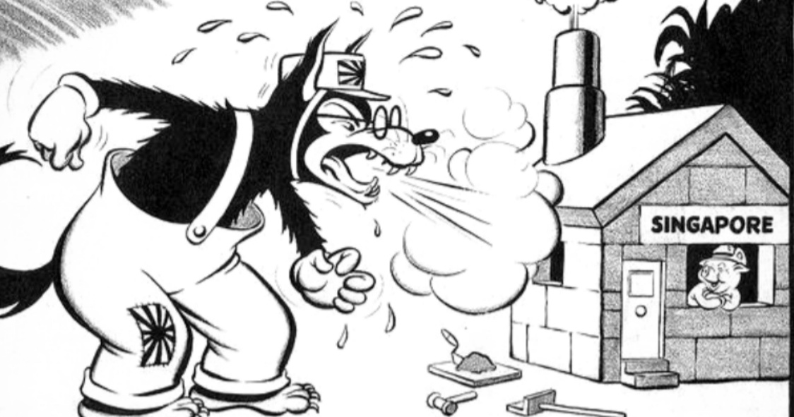

### **Symbols and Exaggeration**

* **Look at Everything**: Characters, objects, and actions. Focus on details like facial expressions, body language, and the setting.
* **Notice Symbols and Exaggeration**:
  + **Symbols**: What do objects or animals represent (e.g., a dove = peace)?
  + **Exaggeration**: Are certain features (like big noses or tiny bodies) or actions shown in extreme ways? What does this emphasize?

### **Text and Tone**

* **Check for Text**: Read captions, labels, or speech bubbles. They can explain the cartoon or add humour.
* **Understand the Tone**: Is it serious, funny, or sarcastic?

### **Actions**

* **What’s the Cartoon About?** Think about the historical event or issue it’s addressing.
* **What’s the Opinion?** Is the cartoonist supporting or criticizing something? Look for clues in the characters, actions, and symbols.

### **Purpose**

* **Why Was It Created?** Is it meant to persuade, criticize, inform, or entertain?